Are You Wise?
July 16, 2016
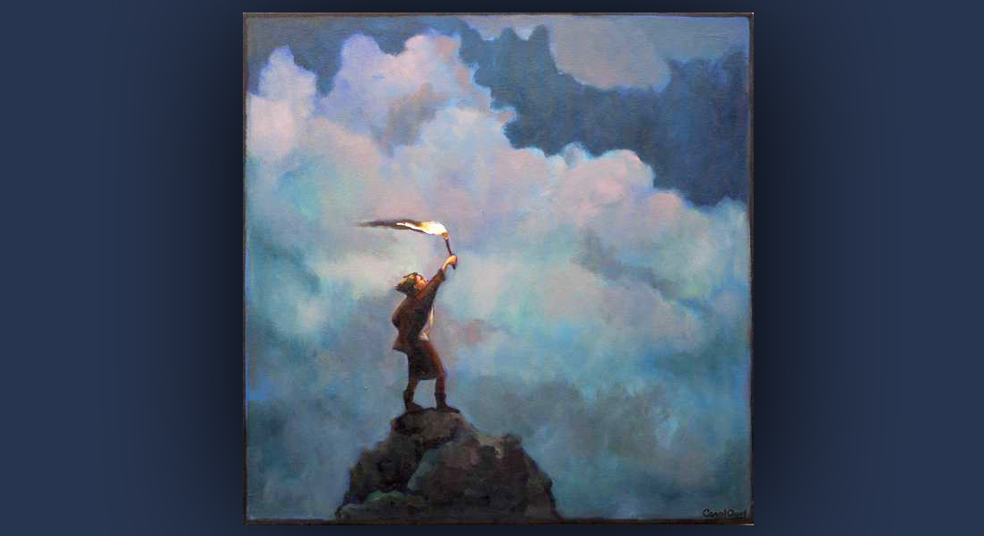
The blessing of God’s wisdom is with us, Heartdwellers. Our only task is to access and implement it. He had a lot to say about that tonight.

This ’day’ began with my hours going topsy-turvey. Normally, I like to get up while the sun is shining, but unfortunately I was going to bed when the sun was rising...But it turns out to be for the best, because July heat doesn't work too well for me.

I worked on the painting of Jesus last night and it is beginning to take a good direction. But I decided I needed a couple more things for the painting. Since this is my weak spot, I checked with Jesus first…and this turned out to be today’s message.

He began, “Do not distress yourself about night hours, they are better for you. Let it rest for now. And do not allow yourself to get even a little warm…you’re doing all the right things. I just wanted you to know that. And on that topic of doing the right thing, thank you for checking with Me first about buying another paint brush. We have more than enough to finish with, Clare."

And here, I was going to go to the store to buy another brush and two tubes of color, but I got Pride in the Bible Promises, and I knew it wasn't His will and only another opportunity for foolishness on my part.

So, I answered Him, "Thank you, Lord, for preserving me."

He replied, "Thank you for asking Me first. That’s real progress."

Well, I have decided that grieving You is so painful it’s not worth the convenience of having another brush or tube of paint, or whatever.

"That’s exactly what I meant when I said, 'You will love Me so much you will not want to grieve Me in any way'…no matter how hard the demon of Avarice stomps on your “Gotta have” buttons. This is precisely what I meant.

"Obedience in the little things leads to obedience in the big things, and for those left behind, obedience may mean life or death. So, now is the time to seek My will, to be sure you are moving forward in obedience and not in self-will."

I worry for some, Jesus. I know they don't like to check with You about things. They think it's childish, or maybe it doesn't work. They just...are "too smart" for that. Too intelligent for that. It worries me...

The Lord continued, "Well, some will learn the hard way and some will never learn. The problem with seeking Me before you buy something is PRIDE. Some think they know what I want and they don’t need to consult Me. It isn’t until everything goes wrong that the seek Me.
"It is not the insecure and unschooled that are in danger; it is those who think that because they are educated they don’t need My opinion. They have learned to think on their own and for the most part see consulting Me as a weakness and only for the simpletons. That is precisely the reason why the poor recognized Me when I came and the Pharisees and Scribes, knowing the letter of the law so well, tried to kill Me.

"My children, there is nothing worse than Pride. Not murder, not divorce, not adultery, not failure in business, not sickness. Pride is the number one most dangerous thing in your life. And if you think you are without it, you are in fact worse off than most. You have nothing to lose by handing your opinions over to Me for confirmations and everything to gain.

"Nevertheless, if you fail, I will still be with you - it will just be much more difficult for you. Humiliation, sorrow, hurting others - all these things you will have to face because you sought not the counsels of your God. How I wish some of you would listen to Me. How I have tried to reach inside of you and coaxed you to use the childish ways of discernment before doing something! In essence, I have asked you to hand over your free-will decisions and let Me advise you."

And I just want to make a confession here, guys. I have been the worst at that. He's been infinitely patient with me. I am so proud and self-willed, you just...you can't even imagine it. And He's continued to work with me again and again. Today was just a real stroke of Grace, because normally I would just vault off and go buy the brush. So, I'm the worst case that you'll ever see, I'm sure. But don't feel badly if you feel convicted when you hear this message, okay?

Okay, picking up where I left off, where the Lord said, "I have asked you to hand over your free-will decisions and let Me advise you.

"To some that is unthinkable. Do you understand that kings sought My oracles, My prophets, before they made any major decisions? Do you know that the ones that followed My counsel were the most successful and those who spurned My counsel led their people into famines to the point where they were eating their own children?

"It is not a little thing to be entrusted with the knowledge of God, and be chosen by God to serve. No, it is a very high calling and requires the utmost amount of dependence on My counsels. The utmost amount of humility and understanding that you don't have all the answers. It is not the educated that will survive; it is the meek and devout who move neither to the left nor the right until they have sought My will.

"How many times in Scripture have I inferred or outright said, 'I have chosen the foolish things of this world to confound the wise?' Read the Beatitudes. My blessings are poured over the very ones this world scorns: the poor, the meek, the grieving, the persecuted. These are the ones no one wants to be, but they are the very ones chosen for My graces. If you would be among them, throw out the purse of your own opinion and seek Me until you find Me, until you hear Me, until you read between the lines of Scripture and hear Me loud and clear.

"Oh, I love your rhema page! What a wonderful opportunity this is for Me to get your attention about something!"

There He's talking about the Heartdwellers website. We have a page where, when you click on the page, a word from the Lord pops up. It's really neat, it's helped a lot of people.

The Lord continued here. "Do you know that many times your mind is a million miles away from My Mind? What an opportunity to get your attention this is. I speak to you all day long. Even when you read Scripture, My voice can be heard between the lines. Ask, 'Lord, how does this apply to me today?' Then listen very carefully. It might only be a tiny word that catches your attention, but it could be a warning that will save your life or open a door to an opportunity you never dreamt possible.

"I long to speak to you, My people. I am forever trying to find new ways to speak to you: through nature, through events, through friends, even through license plates. There are times when I want to turn you around before it is too late to repair the damage you’re going to do. But alas, you just don’t hear Me. Part of the deafness is due to self-will, but part is due also to your lack of belief that I am so involved in your life that I want to tell you what will make a difference for you. I want to advise you, I want to prevent catastrophes, I want to bless you. Oh, you just don’t know or believe in My goodness. It is more than you can ever fathom.

"Rather, there is a place in you that is still in rebellion and wants what it wants. You don’t understand that your way is death and My way is life. You don’t realize that I only tell you what is best for you. Rather, you see Me as a controlling taskmaster that wants it done His Way.

"I wish you would see that I am not a man with selfish motives. I am your God, and I have come that you might have life and have it more abundantly. True life. When you resist Me, you pair up with Satan and the results are painful - and sometimes deadly. When you want what you want without regard for what I want, your choices may be good or they may be bad. But if you’re insisting on your own choice over Mine, it could be very bad for you in the end.

"So, I am begging you: be meek and humble of heart. Be highly concerned about what I think before you do anything. Please, consult Me and know that I already have all the answers you need if only you will seek Me. I promise you, I will be faithful to answer you.

"I am at a loss, My People, to tell you that I have only your very best interests at heart and you can trust Me with your lives and all your decisions. I will never mislead or abandon you. But you have a very real enemy who will use your personal opinions, your fears and your desire nature to lead you into destruction and failure. He is quite talented at using you against yourself. He understands the most subtle ways of manipulation, ways that you don't see coming…but ways that I know all too well.

"You can trust Me. I love you, I am for you. I will lead you in My ways and afterwards take you into Glory."

